**Pythagoras theorem Exercices**

**Exercice 1 :** Calculate the length of the third side of these right angled triangles.

**D**

**L**

**M**

1. 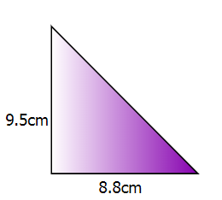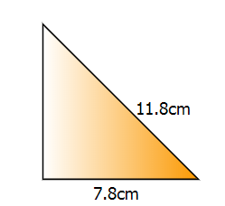 b)

**A**

**?**

**?**

**F**

**B**

**Exercice 2 :** A rectangular swimming pool is 15m wide and 40m long.   
Calculate the length of a diagonal in metres to 1 decimal place.

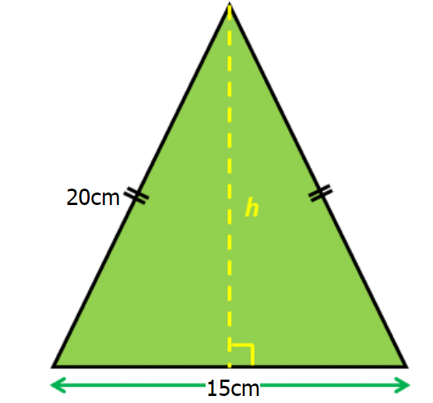**Exercice 3 :** Find the height (h) of this isosceles triangle to one decimal place.

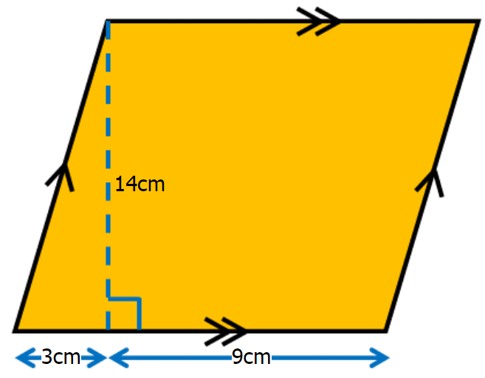**Exercice 4 :** Find the perimeter of this parallelogram to one decimal place.

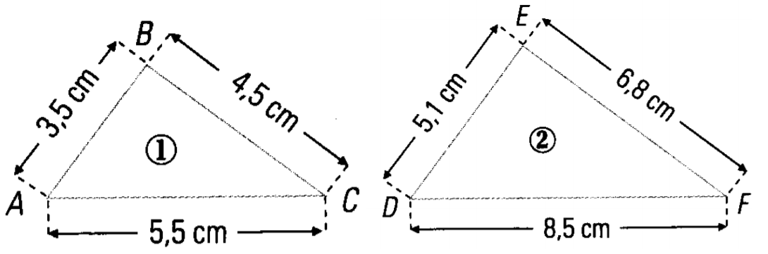**Exercice 5 :** Does this triangles has a right angle?

C

**Exercice 6 :** Does TUS triangle has a right angle ?

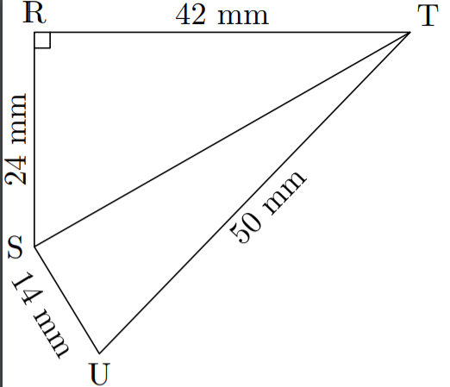

C